THE INSILICO LAB
3-Week Virtual Training in CADD
Week 1

Protein Target Selection, Binding Site Analysis & Protein Preparation

Participant Name  __Caren Nicole Moreno __________________________ | Date Submitted  _____________07/09/2026__________________
Cohort / Batch  Cohort 5_______________________________ | Email Address  ____carenmoreno28@gmail.com_________________

📋 Instructions
Read all instructions carefully before starting. Each task builds on the previous one. Submit all deliverables to the spaces provided in this template.

TASK 1 | Protein Target Selection and Structure Evaluation

Objective: To demonstrate the ability to select and justify a high-quality protein structure suitable for structure-based drug design.
▸ Task Description
1 | Select the Crystal structure of Human Dihydrfolate Reductase (PDB ID: 1U72).
2 | Go to the Protein Data Bank website: https://www.rcsb.org and search for 1U72.
3 | Download the structure file (.pdb) for visualization.
4 | Open and visualize the structure in PyMOL.
5 | Take screenshots showing the full protein and the co-crystallized ligand.

▸ Deliverables — Complete the Table Below

# | Deliverable | Your Response / Submission
1 | Protein name | Human Dihydrofolate Reductase (DHFR)
2 | Biological relevance of the protein | Human DHFR catalyzes the NADPH-dependent reduction of dihydrofolate to tetrahydrofolate, a cofactor required for purine, thymidylate, and nucleic acid synthesis. It is a key therapeutic target for antifolate drugs such as methotrexate in cancer treatment and for antibiotics such as trimethoprim.
3 | Selected PDB ID | 1U72
4 | Experimental method used | X-Ray Diffraction
5 | Resolution value (Å) | 1.90 Å
6 | Co-crystallized ligand present? | Yes - Methotrexate (MTX), with NADPH (NDP) as cofactor

▸ PyMOL Screenshots
Note
Insert at least two screenshots below: (1) full protein view, (2) close-up showing ligand in binding pocket. Label each image clearly.

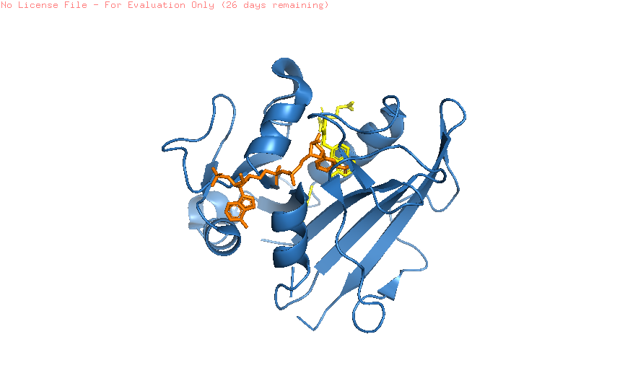
Screenshot 1 — Full Protein View (PyMOL)

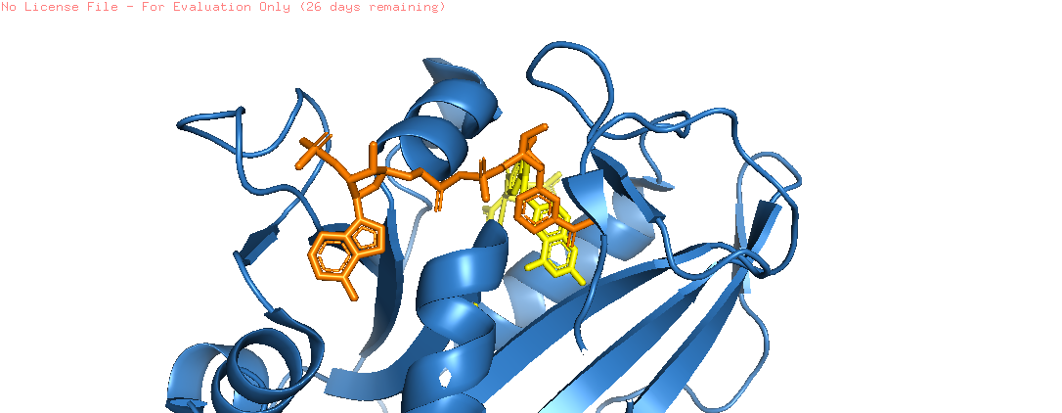
Screenshot 2 — Ligand in Binding Pocket (PyMOL)

▸ Written Justification
Why did you select this structure? Consider resolution, experimental method, ligand presence, and biological relevance. (Write 3–5 sentences below)

The 1U72 structure was selected because of its high resolution (1.90 Å), which provides reliable atomic
coordinates for structure-based drug design. The structure contains the co-crystallized inhibitor
methotrexate, clearly marking the biologically relevant active site. As human DHFR is a well-validated
drug target involved in folate metabolism and DNA synthesis, this structure is highly suitable for
downstream molecular docking studies.

TASK 2 | Binding Site Identification and Analysis

Objective: To demonstrate the ability to identify, analyze, and justify a biologically relevant binding site using the DoGSiteScorer Binding Site Detection website.

▸ Task Description
1 | Go to the DoGSiteScorer website: https://proteins.plus/ and upload your PDB file (1U72).
2 | Run the binding site prediction.
3 | Identify the top-ranked binding pocket and note its key residues.
4 | Open PyMOL and highlight the residues identified by DoGSiteScorer.
5 | Take screenshots showing the binding pocket clearly labelled.

▸ Deliverables — Complete the Table Below

S/N | Deliverable | Your Response / Submission
1 | Tool used for binding site prediction | DoGSiteScorer (proteins.plus)
2 | Chain used for analysis | Chain A
3 | Name / rank of top binding pocket | Pocket P_0 (Drug Score 0.81, Volume 1292.16 Å³)
4 | Key residues in the binding site (list at least 5) | Ile7, Asp21, Glu30, Phe31, Phe34, Ser59, Lys68, Arg70, Val115, Tyr121
5 | Brief explanation of how the tool works | DoGSiteScorer scans the protein surface using a grid-based geometric algorithm to detect cavities, then ranks them by volume, shape, and a Drug Score that estimates their likelihood of binding a small-molecule ligand effectively.

▸ PyMOL Screenshots — Binding Pocket
Note
Insert a screenshot: (1) binding pocket of the protein

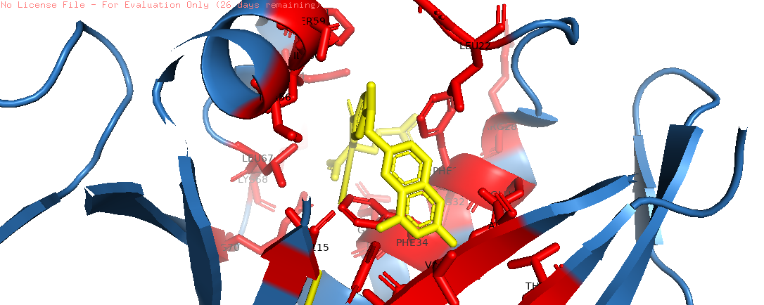
Screenshot 3 — Binding Pocket (PyMOL)

▸ Brief Validation Notes
Explain how you confirmed this is the correct binding site. (Write 2–4 sentences below)

The top-ranked pocket (P_0) was confirmed as the biologically relevant binding site because its residues
spatially overlap with those surrounding the co-crystallized ligand methotrexate, as visualized in
PyMOL. This match between the predicted pocket and the experimentally observed ligand position
validates the accuracy of the prediction.

TASK 3 | Protein Preparation and Cleaning

Objective: To demonstrate the ability to prepare a protein structure for molecular docking following best practices.

▸ Task Description
1 | Open 1U72 in UCSF Chimera (File → Open → select your PDB file).
2 | Inspect the structure: identify water molecules, co-factors, and alternative chains.
3 | Select Chain A only and delete all other chains if present
4 | Remove irrelevant water molecules and any unwanted cofactors/ligands.
5 | Use Dockprep (Tools → Structure Editing → Dock Prep) to add hydrogen and charges.
6 | Save the prepared structure as a new PDB file (e.g., 1U72prepared.pdb).
7 | Open both the original and prepared files in PyMOL for before-and-after comparison.

▸ Step-by-Step Preparation Summary
Fill in each step you complete. Be concise and specific.

Step | Action Performed | Observation / Result
1 | 1U72.pdb was opened in UCSF Chimera | Structure loaded successfully, 1 chain visible
2 | Inspection of water molecules, cofactors, and alternative chains | Crystallographic water molecules and the cofactor NADPH were identified.
3 | Selecting Chain A Only | There were no additional chains to remove (monomeric structure)
4 | Removal of irrelevant water | Non-structural water molecules were removed
5 | Dock Prep (Tools → Structure Editing) | Hydrogens and partial charges were added.
6 | Saved as 1U72prepared.pdb | File exported successfully
7 | Before/After Comparison in PyMOL | Structure ready for docking

▸ Before-and-After PyMOL Screenshots
Note
Show the protein BEFORE preparation (raw PDB) and AFTER preparation (cleaned, one chain, hydrogens added). Both images should be at the same zoom level for easy comparison.

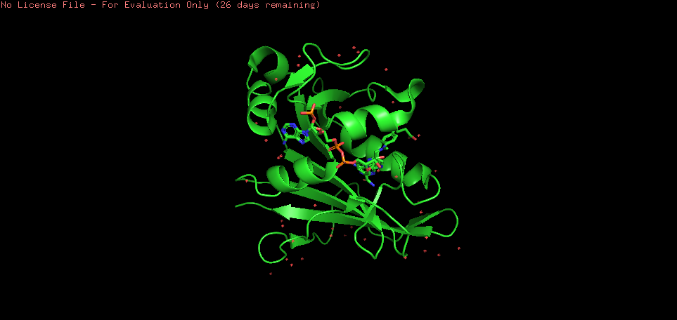
Screenshot 4 — BEFORE Preparation (raw 1U72 in PyMOL)

[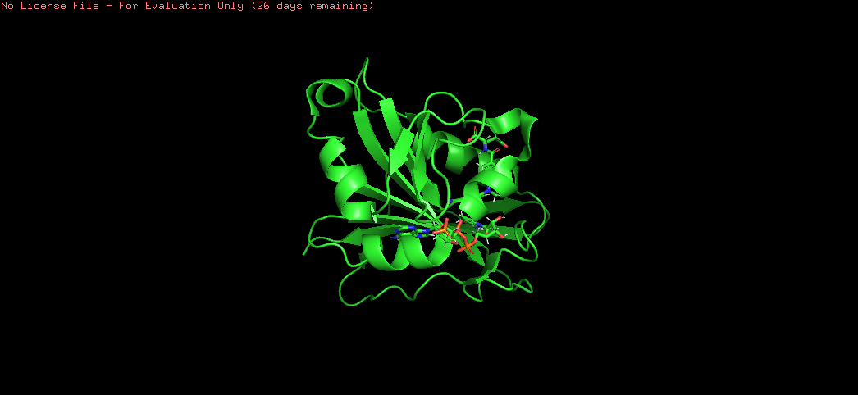
Screenshot 5 — AFTER Preparation (1U72prepared.pdb in PyMOL)

▸ Prepared Structure File
S/N | Deliverable | Your Response / Submission
1 | Prepared PDB file name | 1U72prepared.pdb
2 | Number of chains remaining | Chain A
3 | Water molecules removed? | Yes
4 | Hydrogens added via Dockprep? | Yes
5 | Any issues encountered? | None

📣 LINKEDIN PORTFOLIO POST
Week 1 — Required Submission

Important
This is ONE single post combining all three tasks. Do NOT create three separate posts.

▸ What to Include in Your Post

# | Deliverable | Your Response / Submission
1 | Annotated PyMOL image of selected protein (Task 1) | 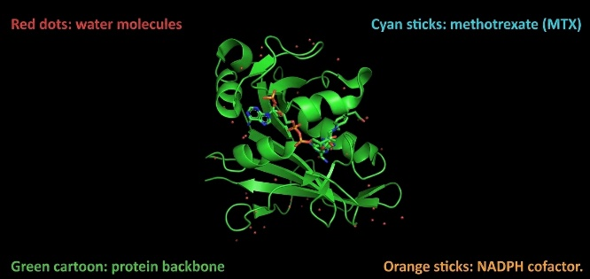
2 | Caption: why this structure was chosen (Task 1) | 1U72 was selected for its high resolution (1.90 Å) and the presence of the co-crystallized inhibitor methotrexate, which clearly marks the active site - making it an ideal model for structure-based drug design.
3 | PyMOL image highlighting the binding pocket (Task 2) | 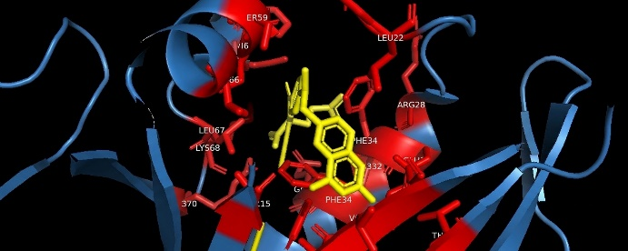
4 | Caption: how the binding site was identified (Task 2) | Using DoGSiteScorer, the top-ranked pocket (P_0, Drug Score 0.81) was identified and confirmed in PyMOL to spatially overlap with the methotrexate binding site, validating its biological relevance.
5 | Before-and-after protein preparation images (Task 3) | 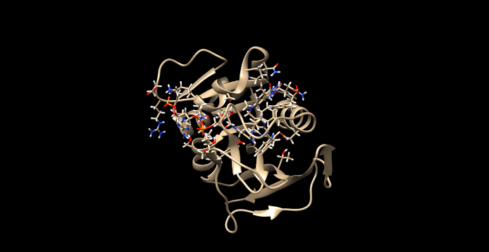
6 | Caption: why protein preparation matters (Task 3) | Protein preparation in UCSF Chimera removing water molecules and adding hydrogens/charges via Dock Prep ensures the structure is accurate and reliable for downstream molecular docking studies.

▸ Tagging & Hashtags
Tag: @The Insilico Lab

#CADD | #DrugDiscovery | #ComputationalBiology | #VirtualResearch | #TheInsilicoLab | #Chemoinformatics

End of Week 1 Assignment
Good luck! The Insilico Lab Team

